Breast Reconstruction

General Timeline:
0 months : Mastectomy and breast reconstruction –

    - Tissue expander placement
    - Flap based reconstruction:
      - TRAM (Transverse-Rectus Abdominus Musculocutaneous)
      - DIEP (Deep Inferior Epigastric Perforator)
      - Latissimus dorsi

3 months: Tissue expander exchange for implant
- Saline implants
- Silicone implants

6 months: Nipple creation and any revision work such as fat grafting

9 months: Nipple tattooing

Note, if radiation is required:
- We may place a tissue expander as a place-holder for a flap until after radiation is completed.
- We may delay exchange of an expander for an implant until 6 months after radiation is completed.

Implant reconstruction:
After mastectomy, a silicone balloon expander is inserted under the skin and muscle of the chest wall. You will have two drains for 1-3 weeks after surgery. Once drains are removed, we will gradually fill the expander with saline, causing the skin to stretch. When the expander has reached a desired size, we wait 3 months before returning to the operating room and exchanging the expander for an implant through the same incision used previously. The implant may be silicone or saline.
Drains are removed when the fluid output is less than 20ml in 24 hours for at least 1-2 days. Drains are removed between 1 and 3 weeks after mastectomy. We will not begin tissue expansion until the drains have been removed.
Tissue expansion is performed by inserting a small needle into a port within the expander. The port is found with a small magnet. You may feel sore and achy after tissue expansion.

Saline versus Silicone Implants –
- Saline Implants –
  - No additional monitoring required.
  - If implant ruptures, the breast with have a deflated appearance and the saline will be reabsorbed by your body.
- Silicone Implants –
  - More natural feel compared to saline implants.
  - Requires MRI monitoring every 2-3 years to assess for silent rupture.
  - If implant ruptures, silicone is not reabsorbed by the body.
  - After extensive research, silicone implants do not increase your risk of a connective tissue disorder or complication.
- Both –
  - Risk of capsular contracture (scar tissue forming around the implant)
  - Risk of implant rupture
  - Risk of poor position
  - Often requires surgery on the opposite breast to improve symmetry
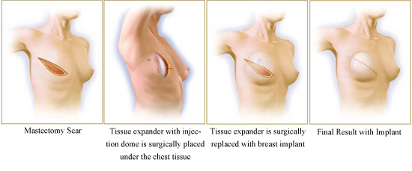
Detailed timeline:
Week 0 – Mastectomy with placement of tissue expander. You will remain in the hospital for 1-2 days after your procedure.
Weeks 1-3 – Drain removal .
Weeks 2-6 – Tissue expansion . The timeline of this is dependent on your desired breast size. Once at the desired breast size, we wait 3 months to let your skin stretch and heal.
Month 4 – Return to the OR for tissue expander exchange to implant and possible symmetry procedures on the opposite breast (eg. Breast lift, breast augmentation)
Month 7 – Return to the OR for nipple creation.
Month 10 – Nipple tattooing in the office.
Pros of this reconstruction:
- Smaller scars and incisions. The tissue expander and implant are placed through the same mastectomy incision (without taking tissue from a distant site). The nipple is created using your mastectomy scar and after tattooing, the scar is less noticeable.
- Surgery is 1-2 hours following mastectomy.
- Stitches are dissolvable.
- Other forms of reconstruction may not be recommended (eg. Prior abdominoplasty)
Cons of this reconstruction:
- This is a longer reconstruction with weekly appointments for drain evaluation and tissue expansion but shorter operative procedures.
- Radiation therapy will change the skin and may cause the skin to contract and tighten, which can lead to asymmetry and a poorer cosmetic result.
- If you receive radiation prior to breast reconstruction, the risk of complications may be significantly higher.
- Capsular contracture – where scar tissue forms and tightens around the implant which can cause pain and asymmetry.
- Higher risk of infection than with reconstructions using your own tissue.

TRAM Reconstruction (Transverse-Rectus Abdominus Myocutaneous):
In this reconstruction the abdominal muscle, fat and skin is tunneled to the mastectomy site to create a breast mound using your native tissue. The abdomen is contoured, excess skin and fat within the abdomen is removed and the belly button is relocated, similar to a tummy tuck or abdominoplasty. This results in a hip-to-hip incision in the abdomen, an incision around the belly button and an incision around the reconstructed breast. The reconstructed breast looks and feels natural and will increase and decrease in size based on your weight.
There will be two drains in the abdomen (one at each side) and a drain within the reconstructed breast. Drains are removed when the fluid output is less than 20ml in 24 hours for at least 1-2 days. Drains are removed between 1 and 3 weeks after surgery.
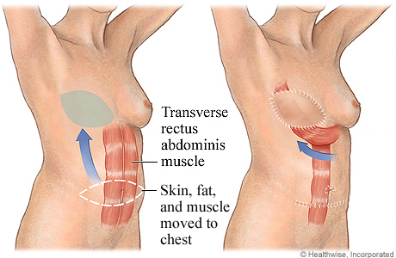

More Detailed Timeline:
Week 0 – Mastectomy with TRAM reconstruction. You will remain in hospital for 3-4 days after your procedure.
Week 1-2 – Drains removal. Remove the belly button stitches (all other stitches are dissolvable).
Week 4 – Follow up. May resume light exercise but no abdominal exercises.
Month 3 – Return to OR for revision(s) of the breast, contralateral symmetry procedures, revision of abdominal incisions, and possible nipple reconstruction.
Month 6 – Nipple tattooing in office.
Pros of this reconstruction :
- Looks and feels similar to a natural breast. This reconstructed breast will change as your body increases and decreases weight and ages.
- Reduced risk of wound and infection complications when radiation is required.
- You have the benefit of an abdominoplasty or “tummy tuck” with this procedure.
Cons of this reconstruction:
- Surgery is an additional 4-6 hours after mastectomy and will be a longer hospital stay (3-5 days). This recovery is also longer – months versus weeks.
- Muscle is used to create the breast mound and removed from the abdomen. Your other abdominal muscles will compensate for losing this one.
- If radiation therapy is required, we will delay placing this “flap” into the breast mound (but may use a tissue expander as a place holder) and will perform the reconstruction after radiation.
- No abdominal exercises for 2+ months.
- There is a “donor site” with risks of hernia and fluid collection.
- Larger scars with hip-to-hip incision, around the belly button and around the breast mound. These will soften and fade with time.
- This surgery may not be an option for you if you have had some prior abdominal operations or a prior abdominoplasty (tummy tuck)

DIEP Flap (Deep Inferior Epigastric Perforator):
In this reconstruction, the skin and fat is removed from the abdomen and separated from its blood supply. This is transferred to the mastectomy site and blood vessels are reconnected in the breast site with the abdominal skin and fat creating a breast mound. The blood vessels are connected through microsurgery and require close monitoring after surgery. With this reconstruction, no muscle is used and there is no loss of abdominal strength. You have the benefit of an abdominoplasty or “tummy tuck” by using skin and fat in the abdomen and will have incisions around the belly button, going from hip-to-hip and around the reconstructed breast mound.
The microsurgery performed to reattach the blood vessels is complex and surgery is 8-12 hours. After surgery, you will be in the ICU overnight to closely monitor the reconstructed breast’s blood supply. A special probe will be placed, called Vioptix, to monitor the blood supply. You will remain in the hospital for 4-5 days. On occasion, if the blood vessels clot, we will return urgently to the operating room to correct this problem. Rarely, this can result in loss of the reconstruction.
There will be two drains in the abdomen (one at each side) and one in the reconstructed breast. Drains are removed when the fluid output is less than 20ml in 24 hours for at least 1-2 days. Drains are removed between 1 and 3 weeks after surgery.
More Detailed Timeline:
Week 0 – Mastectomy with DIEP reconstruction. You will remain in hospital for 3-4 days after your procedure.
Week 1-2 – Drains removal. Remove the belly button stitches (all other stitches are dissolvable).
Week 4 – Follow up. May resume light exercise but no abdominal exercises.
Month 3 – Return to OR for revision(s) of the breast, contralateral symmetry procedures, revision of abdominal incisions, and possible nipple creation.
Month 6 – Nipple tattooing in office.

Pros of this reconstruction:
- Looks and feels like a natural breast and will age like a natural breast.
- No muscle is used in this reconstruction and there will be minimal loss of abdominal strength.
- You have the benefit of an abdominoplasty or “tummy tuck” with this procedure.
- May be a better option if undergoing radiation therapy.
Cons of this reconstruction:
- This is a longer and more complex surgery with use of microsurgery, and potential loss of the reconstruction.
- Surgery is 8-12 hours and requires 1-2 nights in the ICU and 4-5 days in hospital.
- No abdominal exercise for 2 months.
- Larger scars with hip-to-hip incision, around the belly button and around the breast mound. These will soften and fade with time.
- This surgery may not be an option for you if you have had some prior abdominal operations or a prior abdominoplasty.
- This surgery may not be recommended if you have a history of clotting or a clotting disorder.
- This surgery utilizes blood vessels that may be used in cardiac surgery, should the need arise in the future.

Latissimus Dorsi Flap Reconstruction:
In this reconstruction, skin, fat and the latissimus muscle in your back is tunneled and transferred to the front of the chest wall to create a breast mound using your native tissue. This results in an incision along your back and around the reconstructed breast. The reconstructed breast looks and feels like a normal breast. This reconstruction is a good option when considering future pregnancies or if prior abdominal surgery has been performed.
There will be drains in the back and in the reconstructed breast. Drains are removed when the fluid output is less then 20ml in 24 hours for at least 1-2 days. Drains are removed between 1 and 3 weeks after surgery.

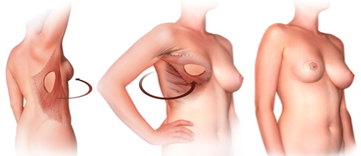

More Detailed Timeline:
Week 0 – Mastectomy with latissimus dorsi flap reconstruction. You will remain in hospital for 1-3 days after your procedure.
Week 1-2 – Drain removal. All stitches are dissolvable.
Week 4 – Follow up. May resume light exercise but no overhead reaching.
Week 6-8 – May resume overhead reaching, heavy lifting and exercise.
Month 3 – Return to OR for nipple creation.
Month 6 – Nipple tattooing in office.
Pros of this reconstruction:
- No loss of abdominal strength.
- Better choice if additional pregnancies are planned or have had major abdominal surgeries in the past.
- Looks and feels like a natural breast. Will age like a natural breast.
Cons of this reconstruction:
- Scar is along the back and around the breast incision and may be difficult to hide.
- Volume of available tissue may be inadequate and need supplementation with an implant (and consequent additional issues associated with implants) or contralateral surgery for symmetry.
- No overhead reaching for 6-8 weeks.

